Task 1: Launch EC2 Instance

Outcome
Launch EC2 Instance completed successfully.

Objective
To perform launch ec2 instance as part of the challenge.

Prerequisites
• AWS Account
• Amazon Linux 2 EC2
• Internet access

Step-by-Step Implementation
Step 1: Perform the task using the commands demonstrated.
Screenshot Evidence:
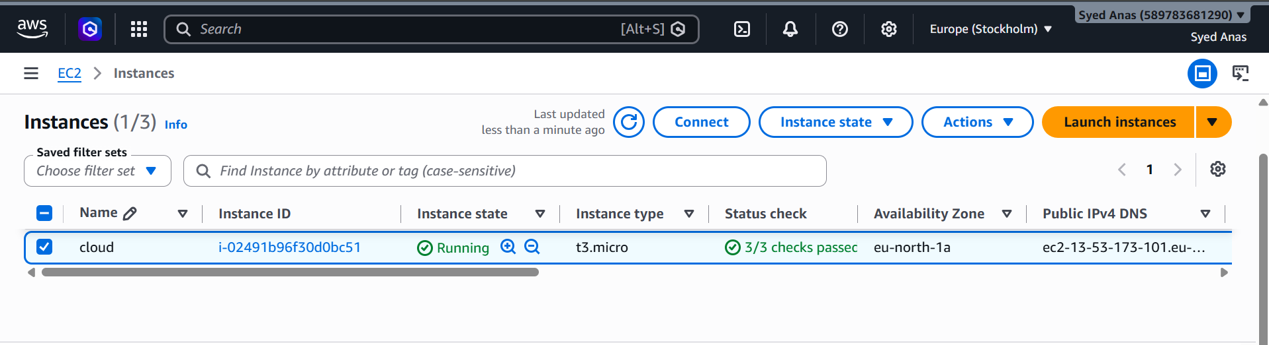

Validation Steps
Verify the service or resource is working correctly.

Explanation
This task configures launch ec2 instance for the server. It is required to build a complete DevOps environment on a single EC2 instance.

Real-Time Use Case
Used in production environments to deploy and manage applications.

Common Errors and Troubleshooting
Error | Cause | Resolution
Service not starting | Configuration issue | Check logs and restart.

Task 2: Connect to EC2

Outcome
Connect to EC2 completed successfully.

Objective
To perform connect to ec2 as part of the challenge.

Prerequisites
• AWS Account
• Amazon Linux 2 EC2
• Internet access

Step-by-Step Implementation
Step 1: Perform the task using the commands demonstrated.
Screenshot Evidence:
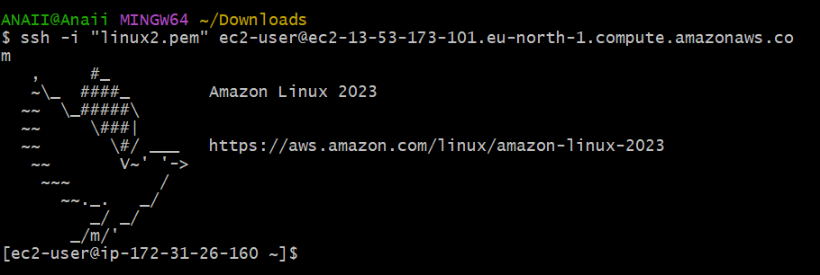

Validation Steps
Verify the service or resource is working correctly.

Explanation
This task configures connect to ec2 for the server. It is required to build a complete DevOps environment on a single EC2 instance.

Real-Time Use Case
Used in production environments to deploy and manage applications.

Common Errors and Troubleshooting
Error | Cause | Resolution
Service not starting | Configuration issue | Check logs and restart.

Task 3: Update Server

Outcome
Update Server completed successfully.

Objective
To perform update server as part of the challenge.

Prerequisites
• AWS Account
• Amazon Linux 2 EC2
• Internet access

Step-by-Step Implementation
Step 1: Perform the task using the commands demonstrated.
Screenshot Evidence:

Validation Steps
Verify the service or resource is working correctly.

Explanation
This task configures update server for the server. It is required to build a complete DevOps environment on a single EC2 instance.

Real-Time Use Case
Used in production environments to deploy and manage applications.

Common Errors and Troubleshooting
Error | Cause | Resolution
Service not starting | Configuration issue | Check logs and restart.

Task 4: Install Docker

Outcome
Install Docker completed successfully.

Objective
To perform install docker as part of the challenge.

Prerequisites
• AWS Account
• Amazon Linux 2 EC2
• Internet access

Step-by-Step Implementation
Step 1: Perform the task using the commands demonstrated.
Screenshot Evidence:
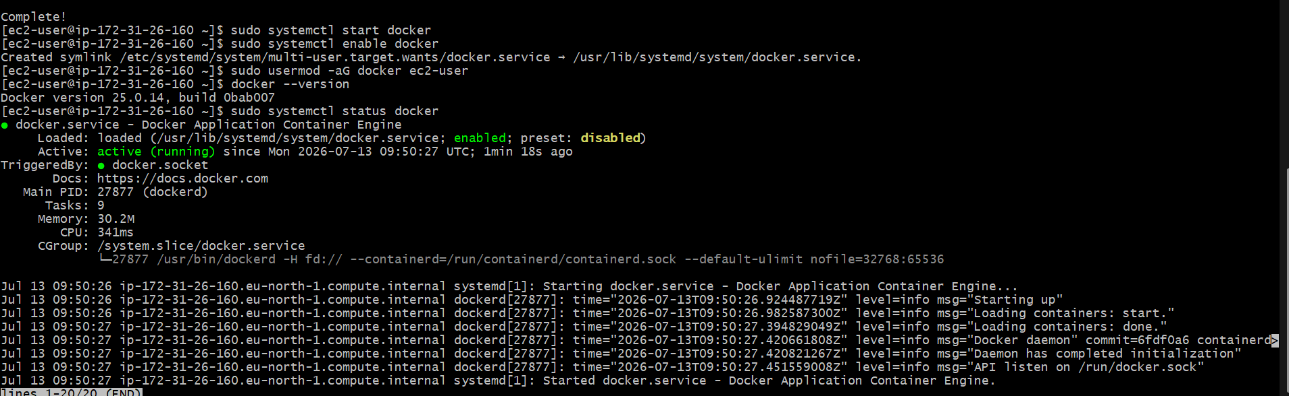
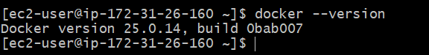

Validation Steps
Verify the service or resource is working correctly.

Explanation
This task configures install docker for the server. It is required to build a complete DevOps environment on a single EC2 instance.

Real-Time Use Case
Used in production environments to deploy and manage applications.

Common Errors and Troubleshooting
Error | Cause | Resolution
Service not starting | Configuration issue | Check logs and restart.

Task 5: Install Java

Outcome
Install Java completed successfully.

Objective
To perform install java as part of the challenge.

Prerequisites
• AWS Account
• Amazon Linux 2 EC2
• Internet access

Step-by-Step Implementation
Step 1: Perform the task using the commands demonstrated.
Screenshot Evidence:
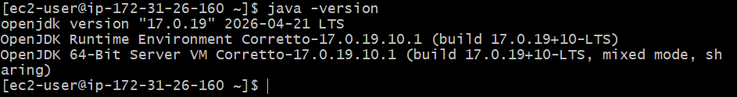

Validation Steps
Verify the service or resource is working correctly.

Explanation
This task configures install java for the server. It is required to build a complete DevOps environment on a single EC2 instance.

Real-Time Use Case
Used in production environments to deploy and manage applications.

Common Errors and Troubleshooting
Error | Cause | Resolution
Service not starting | Configuration issue | Check logs and restart.

Task 6: Install Jenkins

Outcome
Install Jenkins completed successfully.

Objective
To perform install jenkins as part of the challenge.

Prerequisites
• AWS Account
• Amazon Linux 2 EC2
• Internet access

Step-by-Step Implementation
Step 1: Perform the task using the commands demonstrated.
Screenshot Evidence:
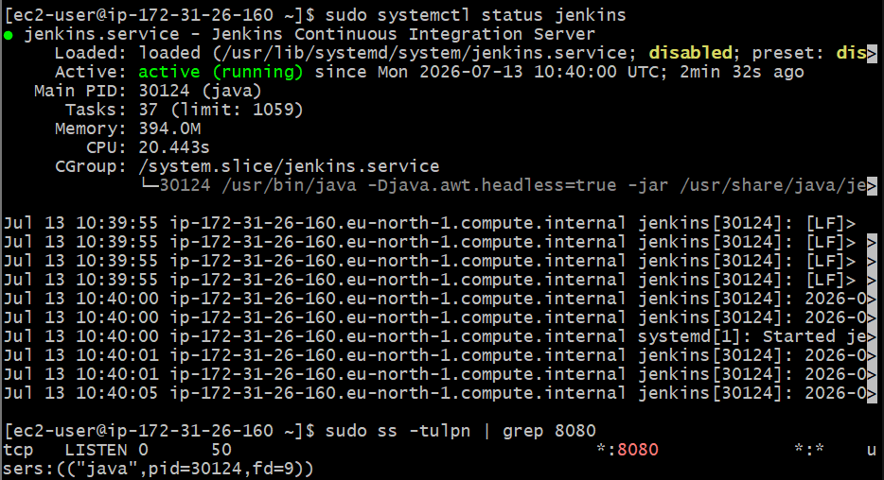
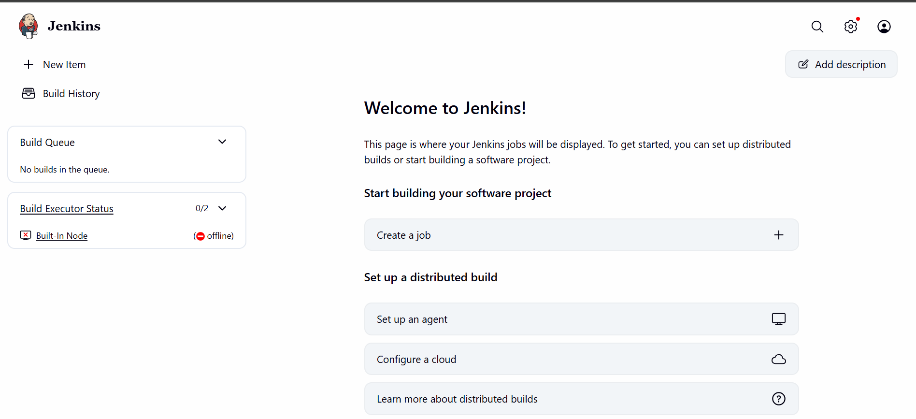

Validation Steps
Verify the service or resource is working correctly.

Explanation
This task configures install jenkins for the server. It is required to build a complete DevOps environment on a single EC2 instance.

Real-Time Use Case
Used in production environments to deploy and manage applications.

Common Errors and Troubleshooting
Error | Cause | Resolution
Service not starting | Configuration issue | Check logs and restart.

Task 7: Install Apache

Outcome
Install Apache completed successfully.

Objective
To perform install apache as part of the challenge.

Prerequisites
• AWS Account
• Amazon Linux 2 EC2
• Internet access

Step-by-Step Implementation
Step 1: Perform the task using the commands demonstrated.
Screenshot Evidence:
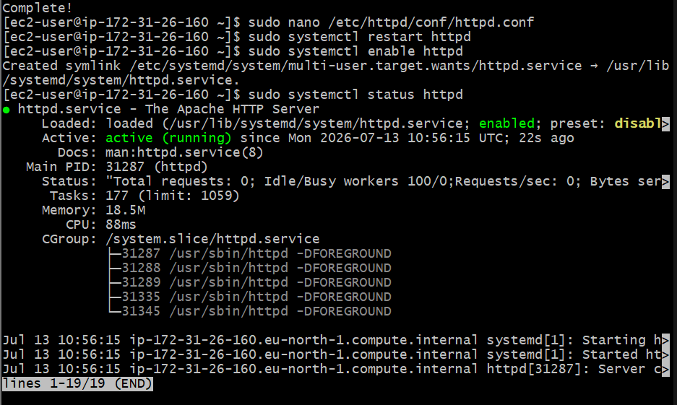
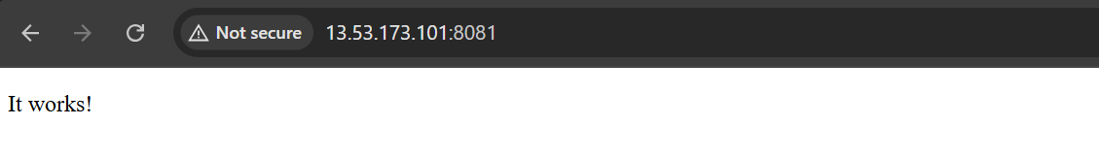

Validation Steps
Verify the service or resource is working correctly.

Explanation
This task configures install apache for the server. It is required to build a complete DevOps environment on a single EC2 instance.

Real-Time Use Case
Used in production environments to deploy and manage applications.

Common Errors and Troubleshooting
Error | Cause | Resolution
Service not starting | Configuration issue | Check logs and restart.

Task 8: Install Nginx

Outcome
Install Nginx completed successfully.

Objective
To perform install nginx as part of the challenge.

Prerequisites
• AWS Account
• Amazon Linux 2 EC2
• Internet access

Step-by-Step Implementation
Step 1: Perform the task using the commands demonstrated.
Screenshot Evidence:
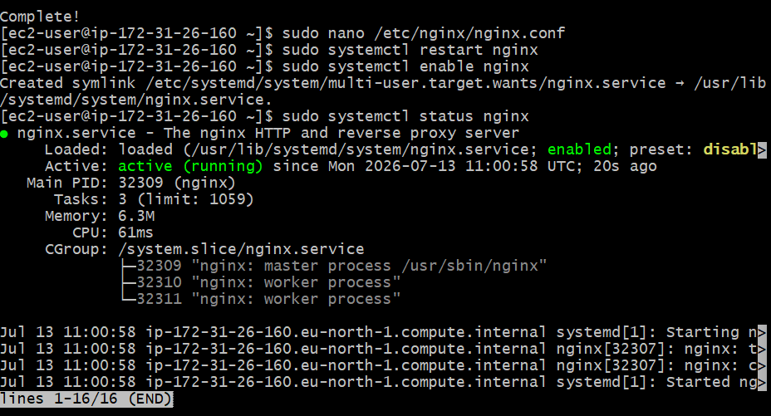
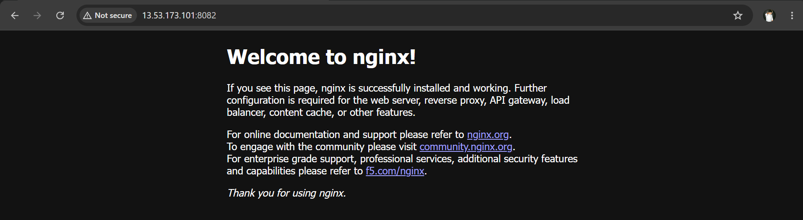

Validation Steps
Verify the service or resource is working correctly.

Explanation
This task configures install nginx for the server. It is required to build a complete DevOps environment on a single EC2 instance.

Real-Time Use Case
Used in production environments to deploy and manage applications.

Common Errors and Troubleshooting
Error | Cause | Resolution
Service not starting | Configuration issue | Check logs and restart.

Task 9: Install Apache Tomcat

Outcome
Install Apache Tomcat completed successfully.

Objective
To perform install apache tomcat as part of the challenge.

Prerequisites
• AWS Account
• Amazon Linux 2 EC2
• Internet access

Step-by-Step Implementation
Step 1: Perform the task using the commands demonstrated.
Screenshot Evidence:
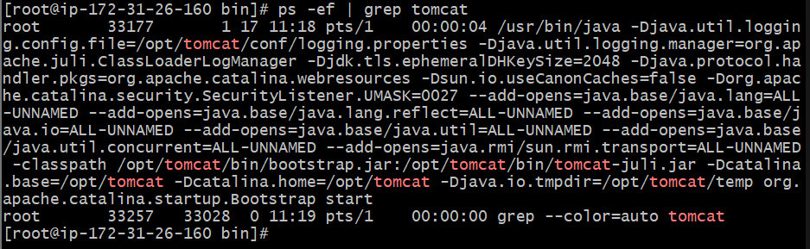
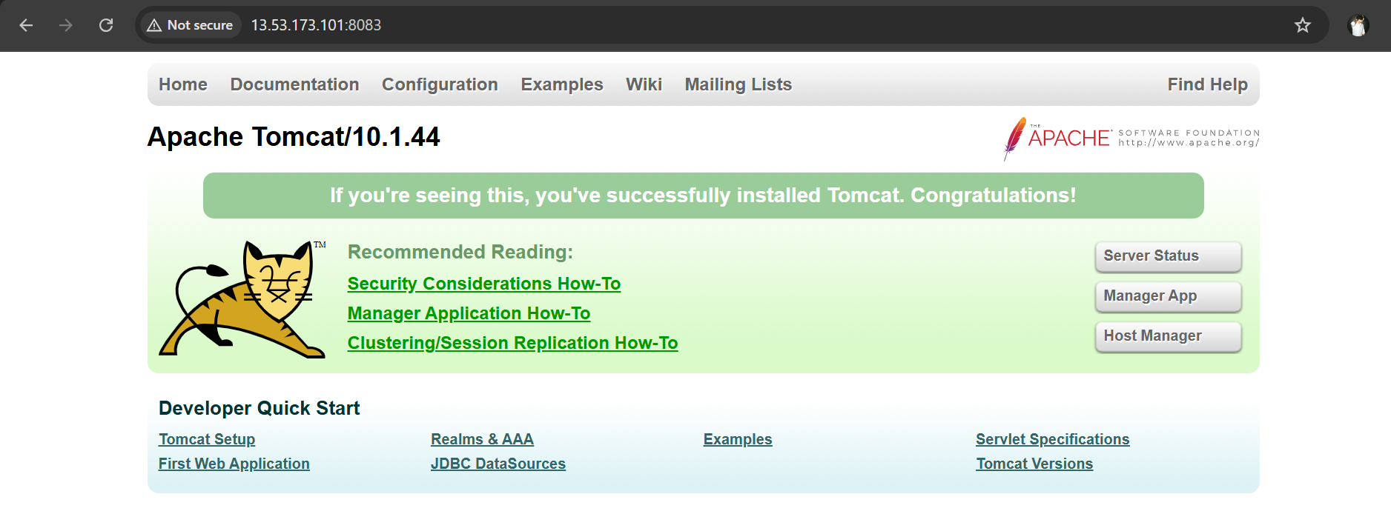

Validation Steps
Verify the service or resource is working correctly.

Explanation
This task configures install apache tomcat for the server. It is required to build a complete DevOps environment on a single EC2 instance.

Real-Time Use Case
Used in production environments to deploy and manage applications.

Common Errors and Troubleshooting
Error | Cause | Resolution
Service not starting | Configuration issue | Check logs and restart.

Task 10: Verify All Services

Outcome
Verify All Services completed successfully.

Objective
To perform verify all services as part of the challenge.

Prerequisites
• AWS Account
• Amazon Linux 2 EC2
• Internet access

Step-by-Step Implementation
Step 1: Perform the task using the commands demonstrated.
Screenshot Evidence:
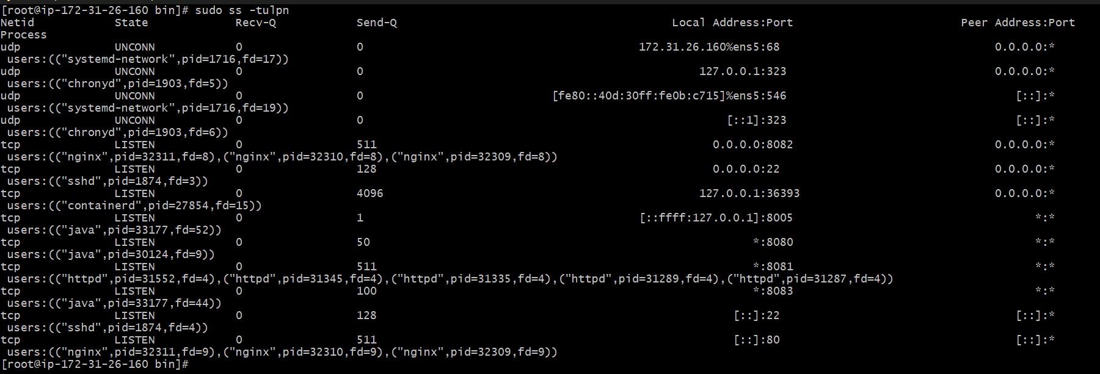

Validation Steps
Verify the service or resource is working correctly.

Explanation
This task configures verify all services for the server. It is required to build a complete DevOps environment on a single EC2 instance.

Real-Time Use Case
Used in production environments to deploy and manage applications.

Common Errors and Troubleshooting
Error | Cause | Resolution
Service not starting | Configuration issue | Check logs and restart.

